Infosys Springboard Virtual Internship 6.0 Completion Report

Team Details <Do not mention any personally identifiable information like email ID, institute details, mobile phone number etc.>

Batch Number: 2 SmartStock Inventory Optimization for Retail Stores
Start date : 10th- Nov 2025
Names:
1.H.Vaishnavi
2.Smriti
3.Aman Kumar
4.Girija Pavani
5.Durga prasad

Internship Duration: 40-days (12 weeks)

1. Project Title
Smart Inventory Management System
2. Project Objective
The primary objective of this project is to design and develop a smart, user-friendly, and secure web-based inventory management system that enables businesses to efficiently track, manage, and control their inventory in real time. The system aims to automate inventory operations, reduce manual effort, and minimize errors associated with traditional inventory management methods.The project focuses on building an interactive frontend for easy inventory monitoring, along with a robust backend to handle data processing, storage, and business logic efficiently. It ensures secure user authentication and role-based access control to protect sensitive inventory data. The system also aims to provide real-time stock updates, low-stock alerts, and analytical insights to support better decision-making. Overall, the project bridges theoretical concepts with practical implementation and offers a scalable solution for modern inventory management.

3. Project description in detail
The Smart Inventory Management System is a web-based application designed to efficiently manage, monitor, and optimize inventory operations for businesses. The primary goal of this project is to automate inventory tracking, reduce manual errors, and provide real-time insights into stock levels, thereby improving operational efficiency and decision-making.
The system enables authorized users to securely log in and manage inventory-related activities such as adding new products, updating stock quantities, tracking incoming and outgoing goods, and monitoring reorder levels. It maintains accurate records of inventory data, ensuring consistency and reliability through proper data validation and secure database storage.
A key feature of the Smart Inventory Management System is its intelligent stock monitoring capability. The system continuously tracks inventory levels and generates alerts when stock reaches predefined minimum thresholds, helping businesses prevent stock shortages or overstocking situations. This proactive approach ensures smooth supply chain operations and minimizes losses.
The application provides a user-friendly and responsive interface developed using modern frontend technologies, allowing users to easily navigate through inventory dashboards, reports, and analytics. Visual representations such as charts and tables help users understand stock trends, product performance, and inventory turnover rates.
On the backend, the system handles business logic, data processing, and secure communication between the frontend and database. It supports efficient data storage, retrieval, and updates while ensuring scalability and system performance. Modular coding practices and proper error handling techniques are applied to enhance maintainability and future extensibility.
Additionally, the Smart Inventory Management System supports role-based access control, enabling administrators, managers, and staff members to access features according to their responsibilities. The system can be extended to integrate with billing, sales, or supplier management modules for comprehensive business automation.
Overall, this project demonstrates the practical implementation of full-stack web development concepts in solving real-world inventory challenges. It bridges theoretical knowledge with hands-on application, enhances problem-solving skills, and provides an effective solution for modern inventory management needs.
4. Timeline Overview
Week | Activities Planned | Activities Completed
Week 1 | Requirement gathering, project scope definition, and resource allocation | Requirements finalized, project scope documented, team roles assigned
Week 2 | Research on AI/ML models for expense forecasting and selection of development tools/tech stack | Suitable ML algorithms shortlisted (e.g., ARIMA, LSTM), tech stack finalized (Python, Flask/Django, React, SQL)
Week 3 | Database design and setup for income/expense data | Database schema created and tested with sample datasets
Week 4 | Data collection, preprocessing, and integration with dummy financial data | Historical expense dataset collected, cleaned, and categorized
Week 5 |  | Initial ML models trained and tested for accuracy with validation datasets
  Model development: Training AI/ML algorithms on expense forecasting
Week 6 | Development of user interface (dashboard, charts, visualization) | Prototype dashboard built with charts for expense categories and forecasts
Week 7 | System integration: Linking AI model, database, and UI | Integrated model with UI, enabled real-time forecasting and alerts
Week 8 |  | Functional testing completed, bugs fixed, user guide prepared, project deployed successfully
  Testing, debugging, documentation, and final project deployment

5a. Key Milestones
Milestone | Description | Date Achieved
Project Kickoff | Project kickoff defined objectives, scope, and roles. | 14-Nov-2025
Prototype/First Draft | Developed the prototype for resume matching and skill recommendation. | 20-Nov-2025
Mid-Term Review | Completed mid-term review to assess progress and refine project approach. | 4-Dec-2025
Final Submission | Submitted the completed Budgetwise project with full functionality and documentation. | 20-Dec-2025
Presentation | Prepared and delivered the project presentation showcasing features and outcomes. | 30-Dec-2025

5b. Project execution details.
• Requirement Analysis – Analyzed existing inventory management issues, gathered user requirements, defined project scope, and finalized functional and non-functional objectives.
• System Design – Designed the overall system architecture, database schema, workflow diagrams, and user interface layout for efficient inventory management.
• Technology Selection – Selected appropriate frontend technologies, backend frameworks, and relational database systems to ensure performance, security, and scalability.
• Frontend Development – Developed a user-friendly and responsive interface with dashboards to display product details, stock levels, and alerts.
• Backend Development – Implemented business logic, user authentication, inventory operations, and secure APIs for smooth communication between system components.
• Database Implementation – Created and managed database tables for users, products, inventory records, and transactions with proper CRUD operations.
• Testing & Integration – Conducted unit testing, integration testing, and system testing to verify functionality, security, and performance; fixed identified issues.
• Deployment & Documentation – Deployed the application on a server environment, validated system performance, prepared documentation, and presented the final demonstration.

6. Snapshots / Screenshots
Step 1 : Go to Github and clone the Repository in your system then open in VS Code to do the execution , here is the github repo link : https://github.com/Girijarajarapu/smart-stock-inventory-optimization-for-retail-stores-
Step 2 : Start the with cd backend & python -m uvicorn main:app --reload
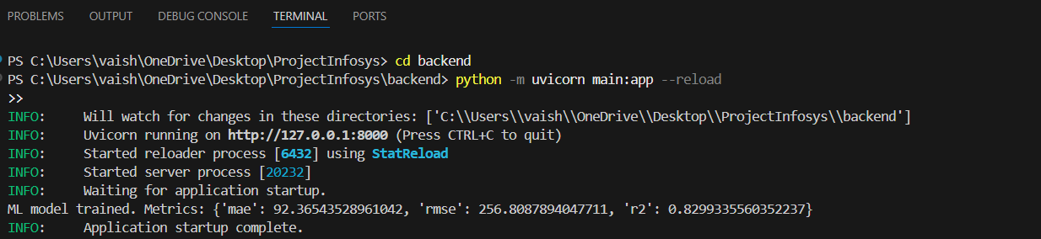

Step 3: here we need to open login.html and right chick and go to open with Live server.
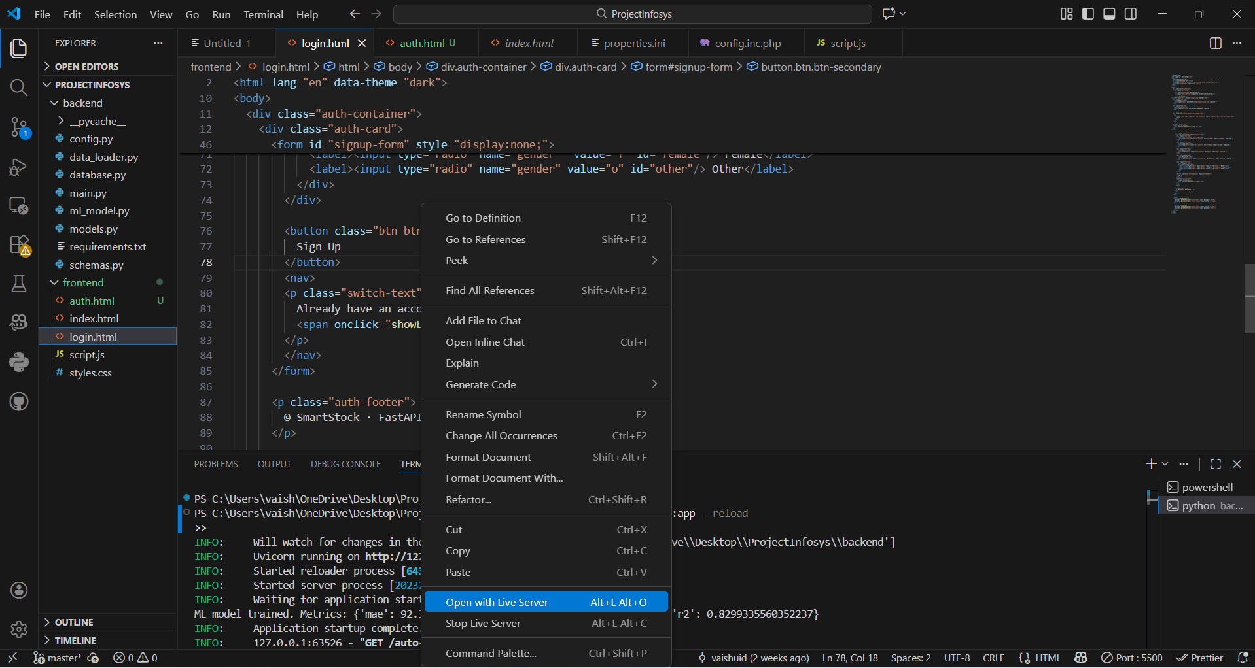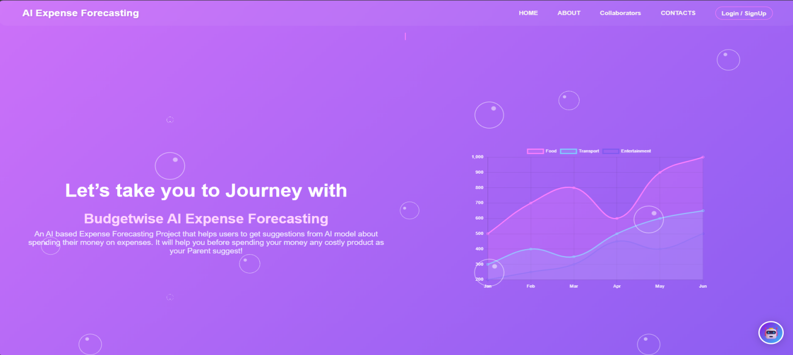

Step 4: After clicking on Login/Signup here user need to register and log in for Authentication.
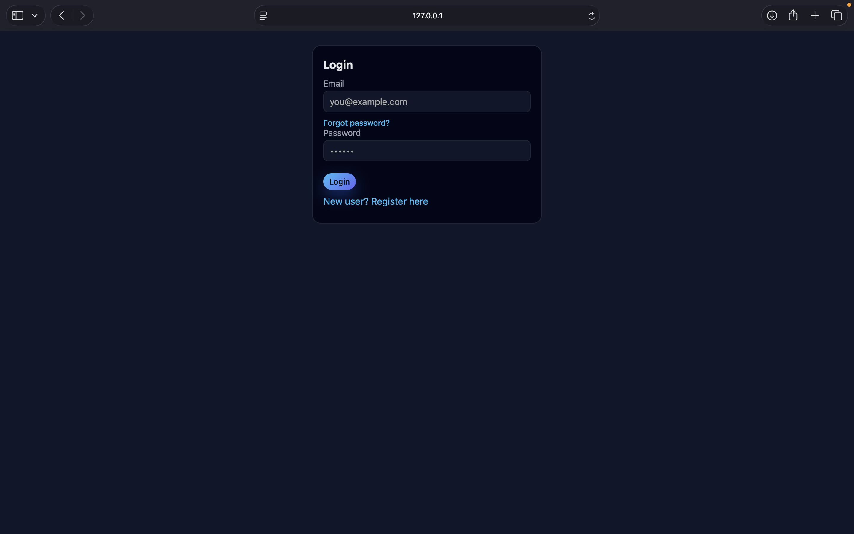

Step 5: then it will open Auto Stock Alers
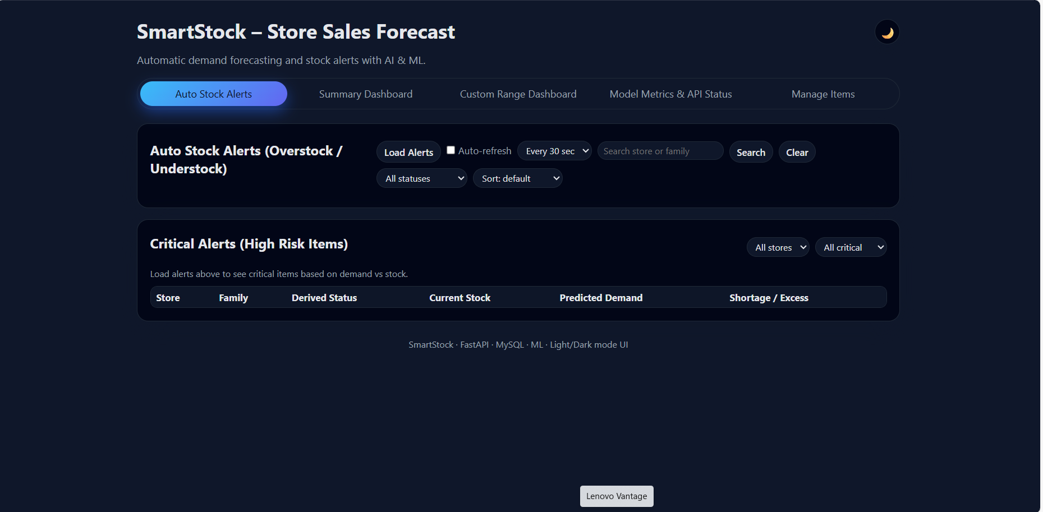

Step 6: When the User What to loard the alert chick on Load alert button.
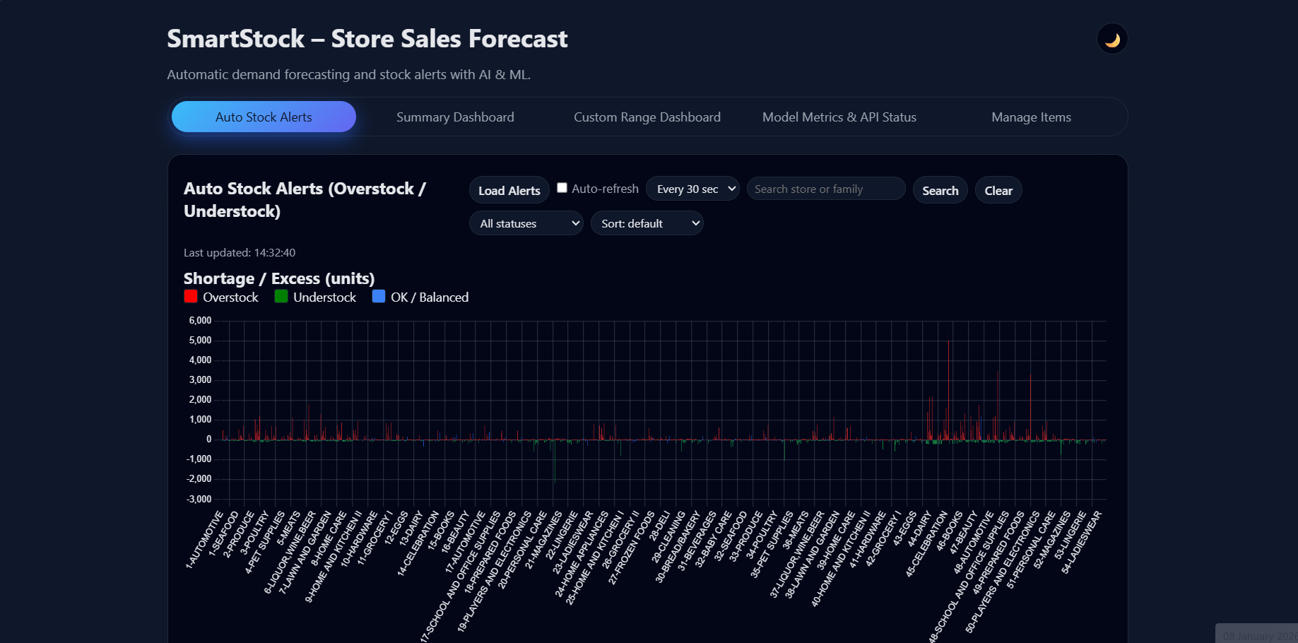

Step 7:Then the next page is Summary Dashboard.
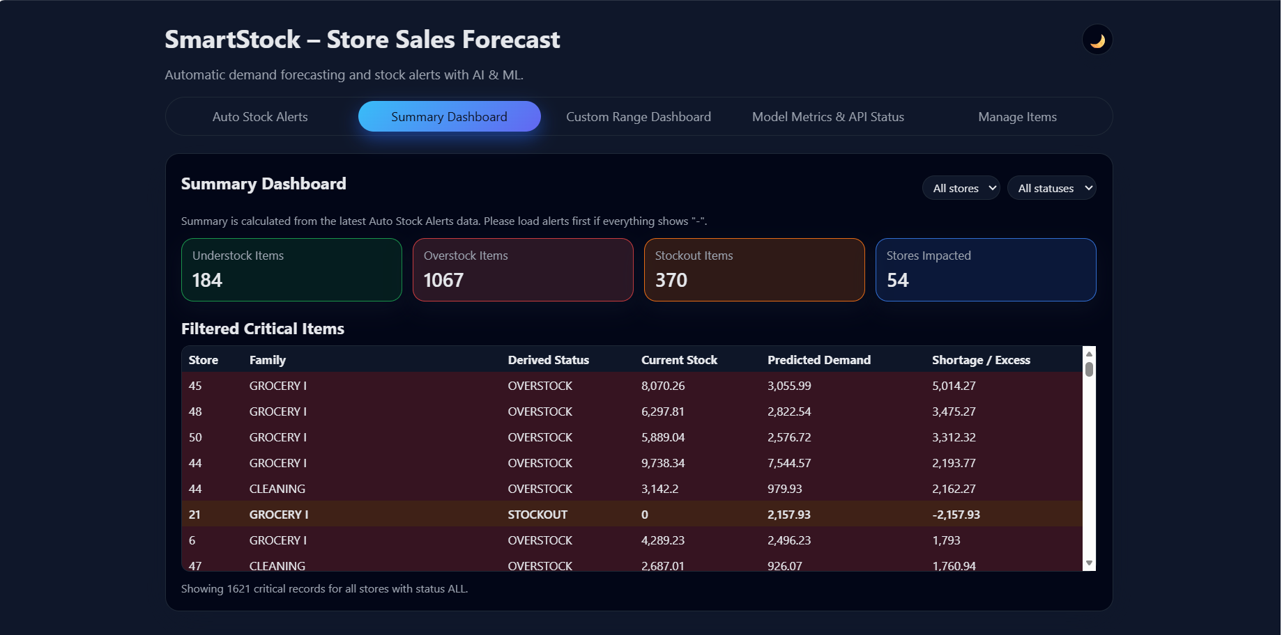

Step 8: Then the next page is Custom Range DashBoard
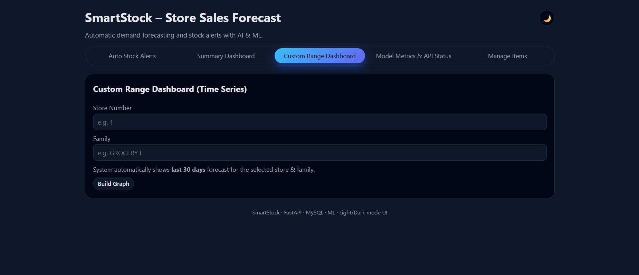

Step 9: Then the next page is Model Metrices & API Status
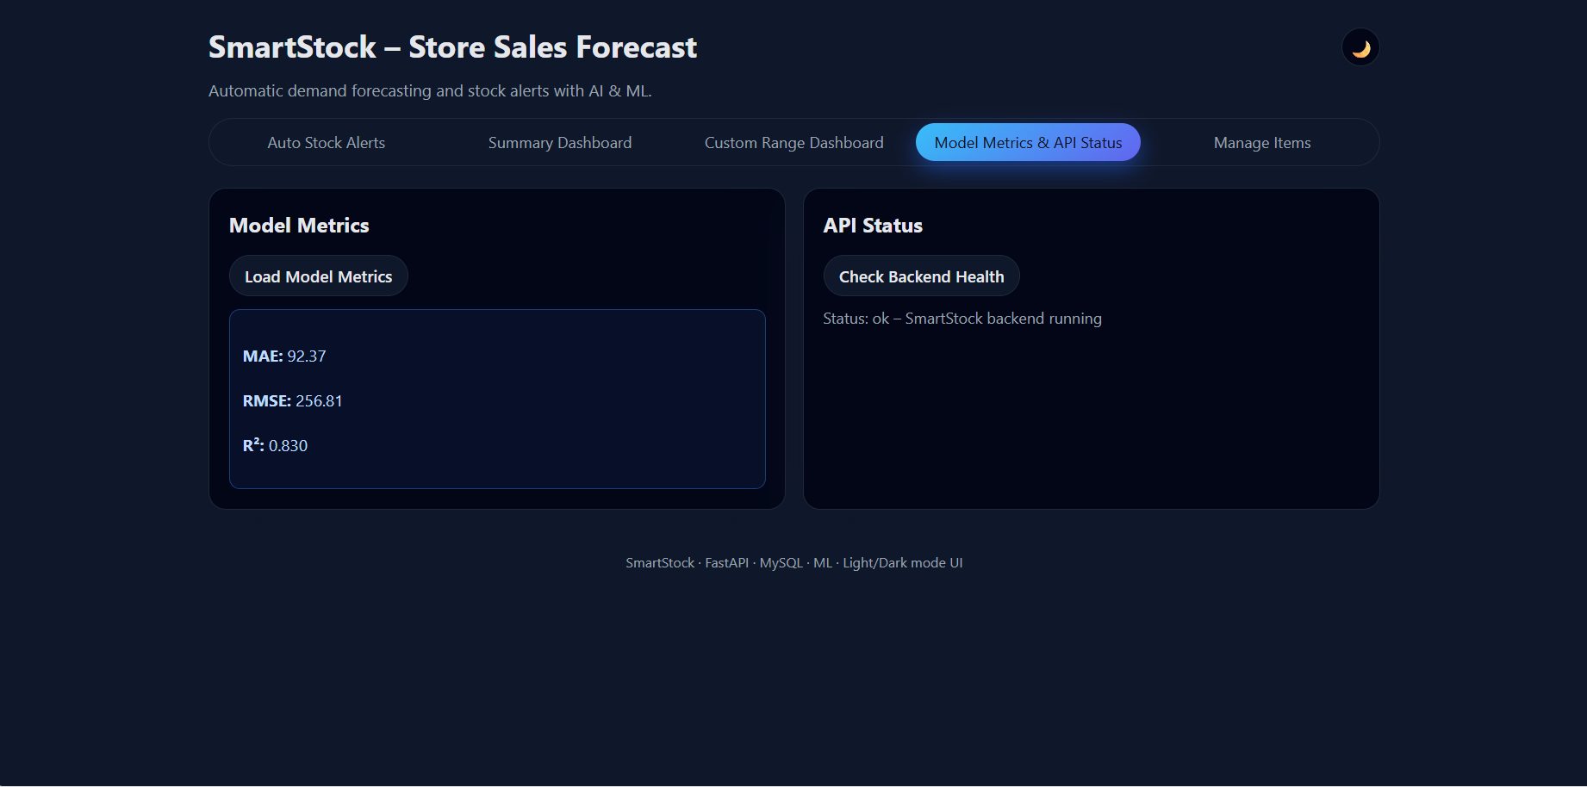

Step 10: Using this you can generate report as pdf.
Step 10:Then the next page is Manage Items
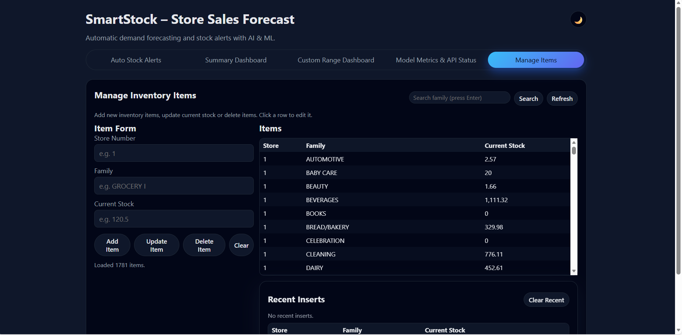

7. Challenges Faced
• Requirement Understanding – Analyzing real-world inventory workflows and converting them into accurate system requirements was challenging.
• Database Design – Designing a scalable and normalized database to manage products, stock levels, users, and transactions without redundancy required careful planning.
• Authentication & Security – Implementing secure login, role-based access control, and protecting sensitive inventory data was a critical challenge.
• Real-Time Stock Updates – Ensuring real-time synchronization between frontend, backend, and database while updating inventory levels without delays.
• Data Validation – Preventing incorrect stock entries, duplicate records, and inconsistent data through proper validation mechanisms.
• Module Integration – Integrating frontend interfaces with backend APIs and database operations smoothly posed compatibility challenges.
• Performance Optimization – Maintaining system performance while handling frequent inventory updates and multiple user requests.
• User Interface Design – Designing a simple yet informative dashboard that clearly displays inventory details, alerts, and reports.
• Testing & Debugging – Identifying edge cases and fixing bugs during unit, integration, and system testing phases.
• Time Management – Balancing development, testing, and documentation within the limited project timeline.

8. Learnings & Skills Acquired
• Requirement Analysis – Gained experience in understanding real-world inventory management problems and converting them into technical requirements.
• System Design Skills – Learned to design scalable system architectures, database schemas, and application workflows.
• Frontend Development – Acquired hands-on experience in building responsive and user-friendly interfaces using modern web technologies.
• Backend Development – Developed strong skills in implementing business logic, RESTful APIs, authentication, and server-side processing.
• Database Management – Gained practical knowledge in designing relational databases and performing efficient CRUD operations.
• Security Practices – Learned to implement secure authentication, authorization, and data protection mechanisms.
• Testing & Debugging – Improved skills in unit testing, integration testing, and resolving real-time system issues.
• Integration Skills – Learned how to integrate frontend, backend, and database components seamlessly.
• Problem-Solving Ability – Enhanced analytical and logical thinking through debugging and optimizing system performance.
• Time & Project Management – Improved planning, teamwork, and time management skills by completing the project within deadlines.

9. Testimonials from team
• Team Member 1 –
“Working on the Smart Inventory Management System enhanced my understanding of full-stack development. I gained practical experience in designing user interfaces, implementing backend logic, and integrating databases effectively.”
• Team Member 2 –
“This project helped me improve my problem-solving skills by addressing real-world inventory challenges. I learned how to analyze requirements, design scalable systems, and handle data efficiently.”
• Team Member 3 –
“Through this project, I developed strong skills in database design, data validation, and system testing. Collaborating with the team improved my communication and teamwork abilities.”
• Team Member 4 –
“The project provided hands-on experience in integrating frontend and backend components. It also improved my understanding of security, authentication, and performance optimization.”
• Team Leader –
“Leading this project strengthened my technical and leadership skills. Coordinating tasks, meeting deadlines, and ensuring quality delivery gave me valuable experience in project management.”

10. Conclusion
The Smart Inventory Management System provides an effective and reliable solution for managing inventory operations efficiently. It automates stock tracking, reduces manual errors, and ensures real-time inventory monitoring. The system integrates a user-friendly frontend with a secure backend and database for seamless performance. It improves data accuracy and supports better decision-making through timely alerts and reports. Overall, the project demonstrates practical application of full-stack development concepts and offers scope for future enhancements.

11. Acknowledgements
I would like to express my sincere gratitude to the organization for providing me with the opportunity to work on the Smart Inventory Management System project and gain practical exposure to real-world software development.
I am especially thankful to my project guide and mentor for their constant guidance, encouragement, and valuable insights throughout the project. Their support and feedback played a significant role in overcoming challenges and ensuring the successful completion of the project.
I would also like to thank the Head of the Department and all faculty members for their academic support, technical guidance, and for providing the necessary resources and infrastructure.
I extend my heartfelt appreciation to my team members for their cooperation, dedication, and collaborative efforts, which made the project execution smooth and successful.
Finally, I sincerely thank my parents and friends for their continuous motivation, encouragement, and support throughout the project duration.

